NAME:VENKATRAMAMOORTHY.G
Question 1:
CODE:
<!DOCTYPE html>
<html lang="en">
<head>
<meta charset="UTF-8">
<meta name="viewport" content="width=device-width, initial-scale=1.0">
<title>Document</title>
<link href="https://cdn.jsdelivr.net/npm/bootstrap@5.3.8/dist/css/bootstrap.min.css" rel="stylesheet" integrity="sha384-sRIl4kxILFvY47J16cr9ZwB07vP4J8+LH7qKQnuqkuIAvNWLzeN8tE5YBujZqJLB" crossorigin="anonymous">
</head>
<body>
<div class="container bg-dark text-white text-center p-5">
<h1>Hello Bootstrap</h1>
<p>This is inside a container.</p>
</div>
</body>
</html>
OUTPUT:
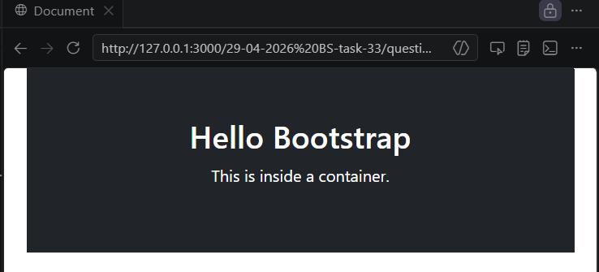
Question 2:
CODE:
<!DOCTYPE html>
<html lang="en">
<head>
<meta charset="UTF-8">
<meta name="viewport" content="width=device-width, initial-scale=1.0">
<title>Typography & Spacing</title>

<!-- Bootstrap CDN -->
<link href="https://cdn.jsdelivr.net/npm/bootstrap@5.3.3/dist/css/bootstrap.min.css" rel="stylesheet">
</head>
<body>

<div class="container mt-5">
<h1 class="text-center text-primary mb-4">
Welcome to Bootstrap
</h1>
<p class="text-center text-secondary mb-5">
This is an example of Bootstrap typography and spacing utilities.
</p>
<div class="bg-danger p-4 mb-4">
<h3 class="text-success">Section 1</h3>
<p>
This section uses padding (p-4) and margin (mb-4).
</p>
</div>
<div class="bg-warning p-3 mt-3">
<h4 class="text-dark">Section 2</h4>
<p>
Bootstrap makes spacing and styling very easy.
</p>
</div>

</div>

</body>
</html>

OUTPUT:
